***Aim : Blink of LED using Switch***

APPARATUS:

LED, Breadboard, wires, arduino, resistor, switch;

CIRCUIT DIAGRAM

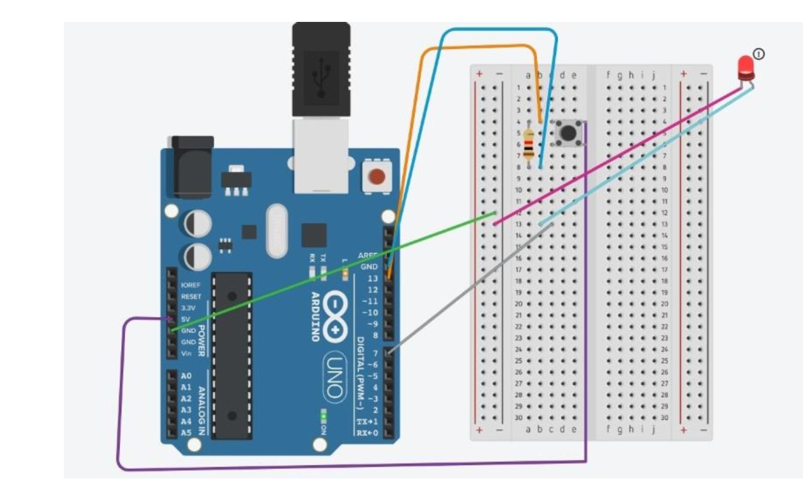

CODE:

char data=0;

void setup() {

Serial.begin(9600);

pinMode(1,OUTPUT);

}

void loop() {

if(Serial.available()>0)

{

data=Serial.read();

Serial.print(data);

Serial.print("\n");

if(data=='1')

digitalWrite(13,HIGH);

else if(data=='0')

digitalWrite(13,LOW);

}

}

Learning and Observations:

1. A push button switch and LED is connected to arduino. 2. When we press the switch, LED will glow for 1 second. 3. You need to connect pull up or pull down resistor while interfacing switch.

Problem and Troubleshooting:

1. Arduino was not working properly and cables were also not working. 2. Mistake in code uploading.

Result:

The LED will glow when we press the switch.